Charles Cundiff
AE498 HW2

Github Repo: AE498/HW2 at main · Charles-Cundiff/AE498
Code Explanation:
This block of code initializes all the parameters and creates Keplerian element arrays.
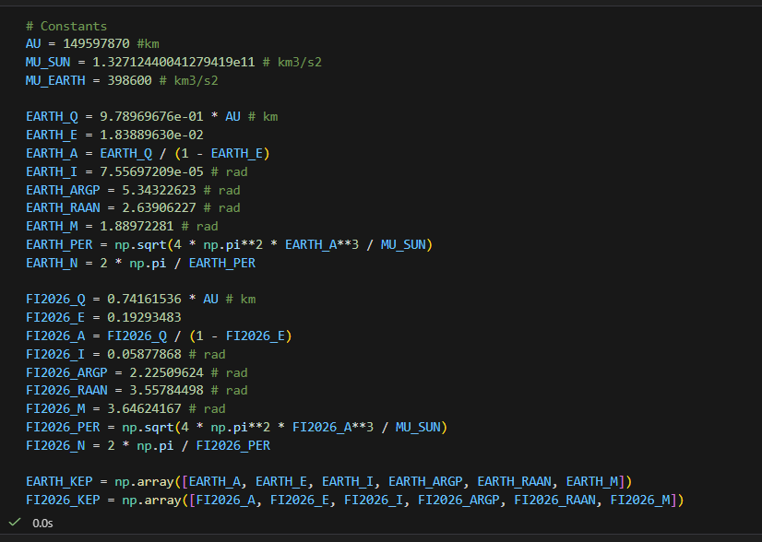

These blocks of code were taken from work in AE402. They convert Keplerian elements to vecs and vecs to elements.
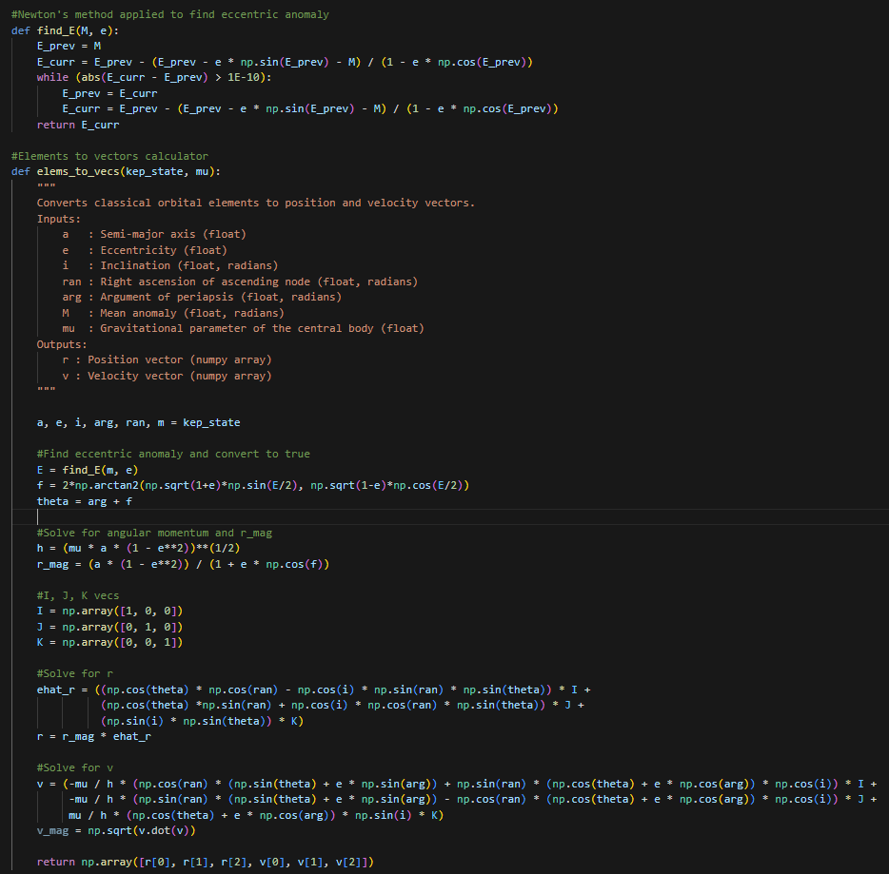
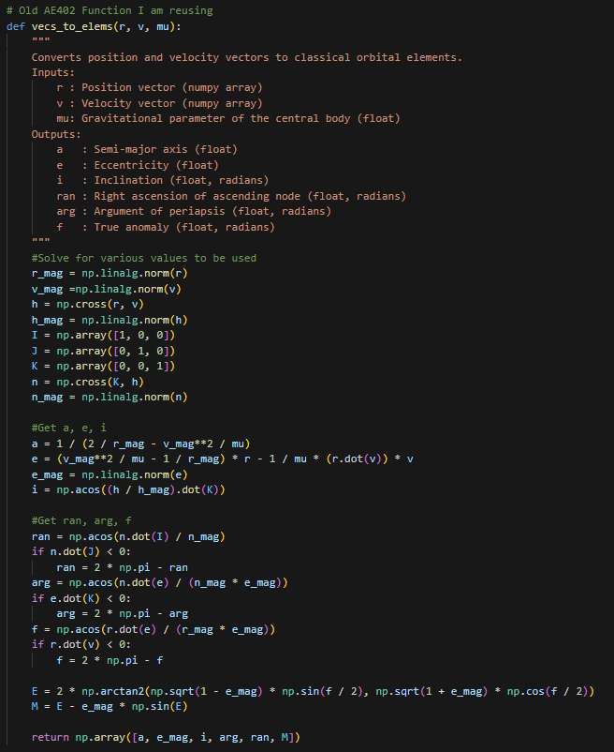

This block of code implements gauss’s planetary equations as an ODE which can be integrated with RK4.
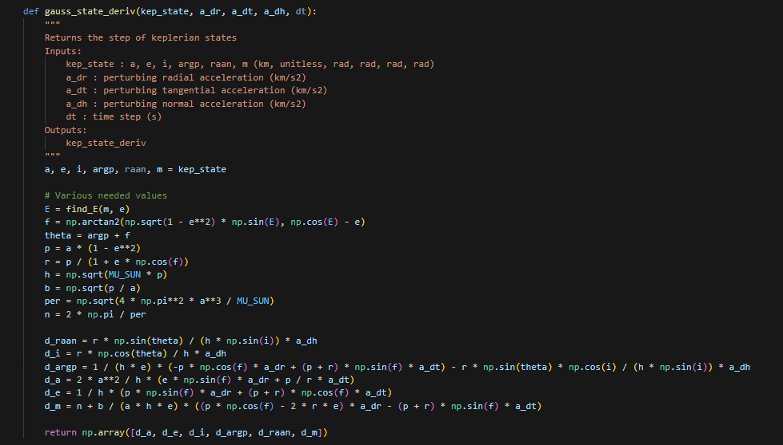

This block of code integrates the Keplerian elements of Earth and FI2026 forwards using my own implementation of RK4. Commented out is a transformation of Earth’s perturbation to the radial, transverse, and out of plane frame. This was added as perturbative accelerations to FI2026. In class, however, it was discussed that this level of detail was not necessary.
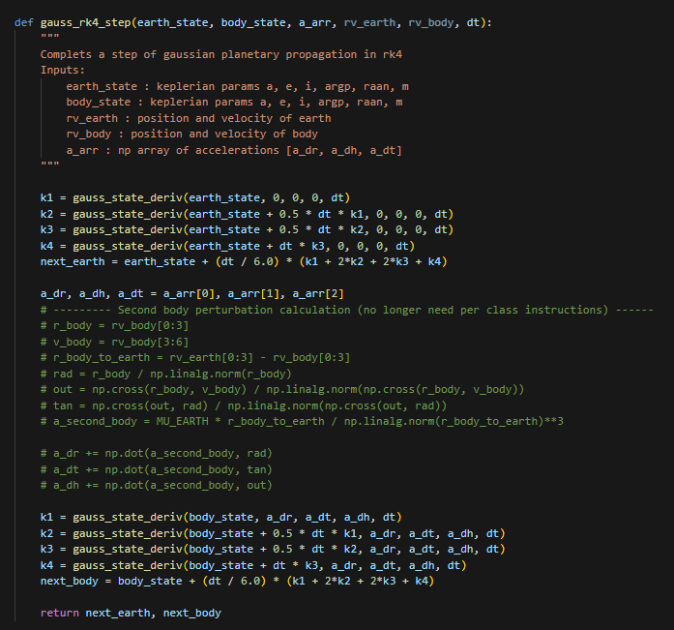

This block of code does the full trajectory propagation for Earth and FI2026 and returns an array of times, Keplerian states, and position-velocity states.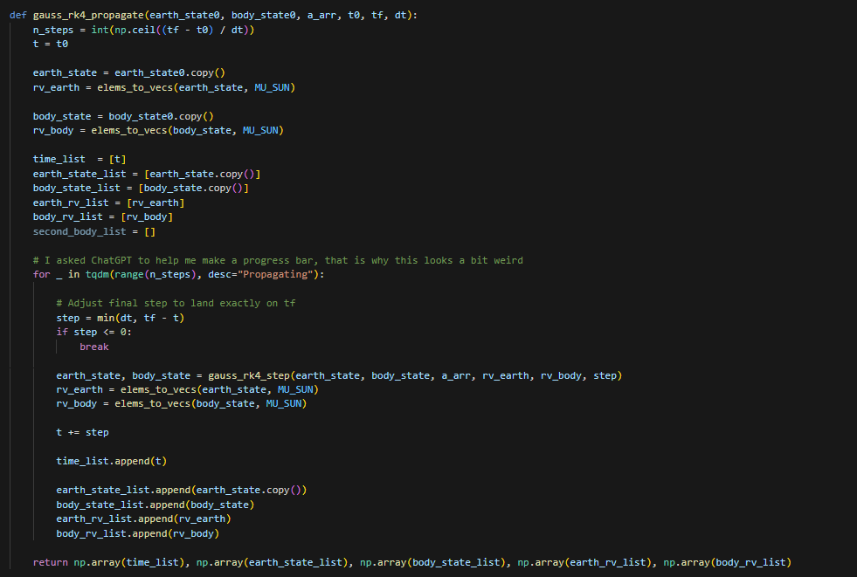

This code does b-plane plotting given earth’s velocity, FI2026’s relative position to earth, and FI2026’s relative velocity all at the time of collision. First, the xi and zeta coordinates are calculated. Then, the Valsecchi circles, if ratios are given, are solved for in plotted. The methods used here are less complicated than those in Valsecchi’s paper as relative velocity is already known and does not need to be calculated.
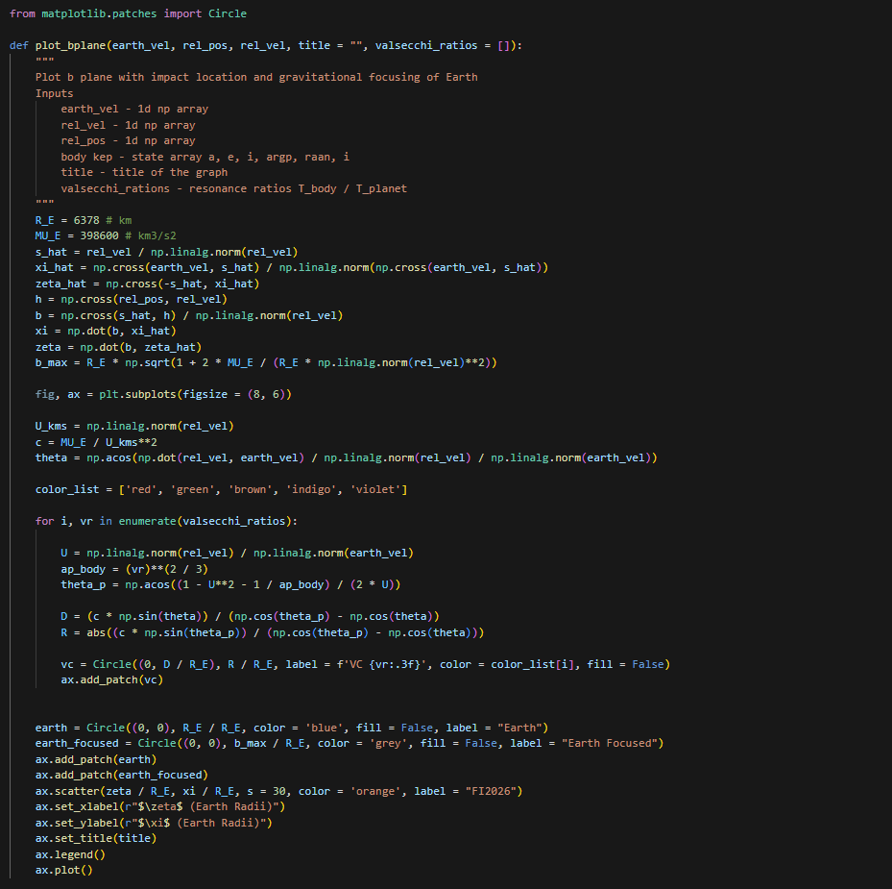

This block of code is an example of how perturbations were added to FI2026. You can see how there is a separate a_arr and dv_arr for continuous and instantaneous accelerations. The instantaneous velocity change is converted to x-y-z coordinates before being added to FI2026’s velocity. Once FI2026’s new position and velocity are calculated, they are transformed back to Keplerian elements. The continuous acceleration is simply fed into the Gauss planetary equations. The collision index is found as the time where relative position is lowest. This works because Earth is not a perturbing acceleration, so FI2026 is on the b-plane when distance is minimized. Admittedly, large time steps may skip over the exact b-plane time, but 1000s was found to work and have minimal changes on the b-plane plot.
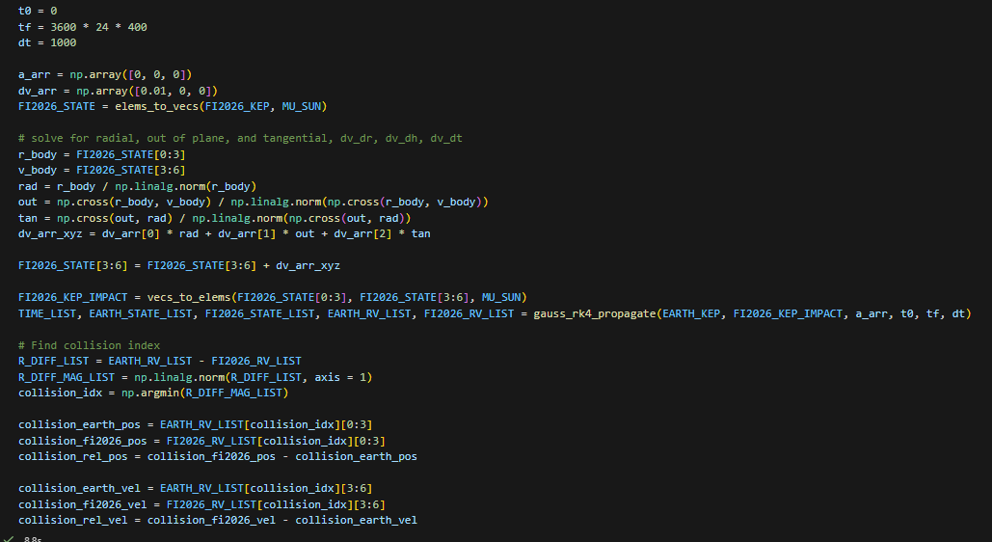
Question 1:
The time to collision = 360 days
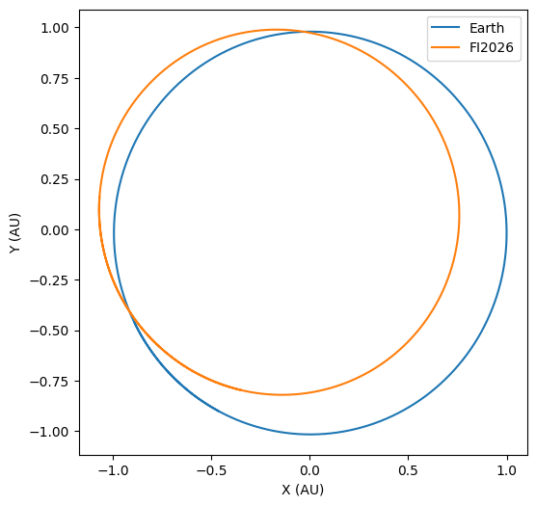
Question 2:
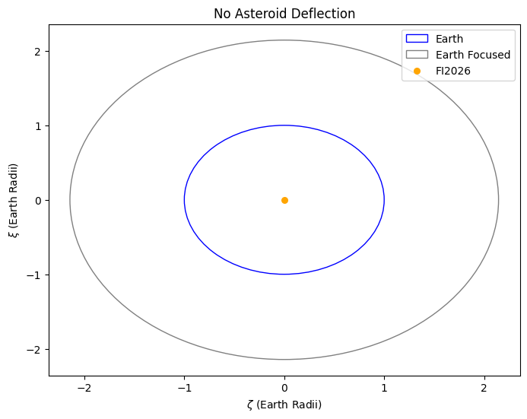

Question 3:
To model continuous perturbations, Gauss’s planetary equations are used. I iterated on each of the three axes in gauss’s planetary equations (radial, out of plane, and transverse) until the asteroid was 4 Earth radii away. The FI2026 marker is hard to find in the first and third image, it is behind the legend. It is easiest to deflect the asteroid when pushing it transversally, needing a continuous acceleration of just 2e-8 m/s2. The equivalent delta-v over this time period was just 0.69 m/s. For an asteroid weighing 7.3e10 kg like Bennu, this is just a 365N continuously applied.
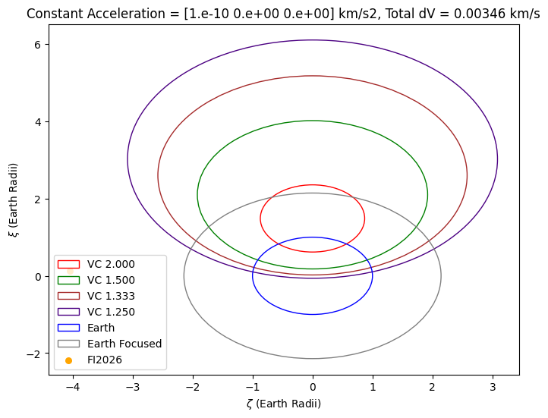
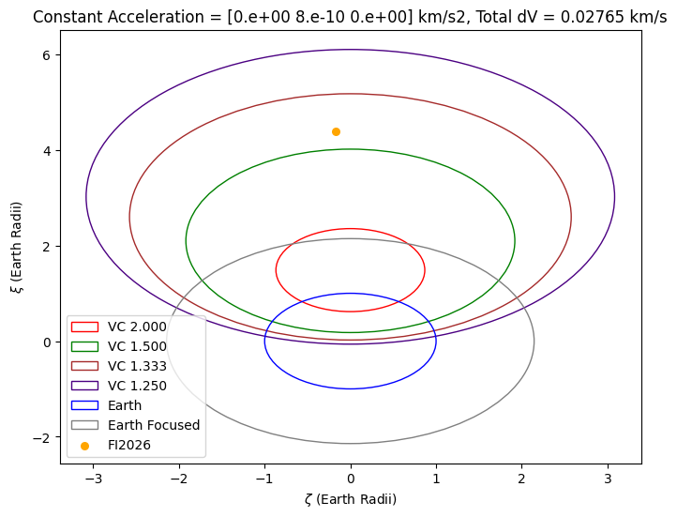
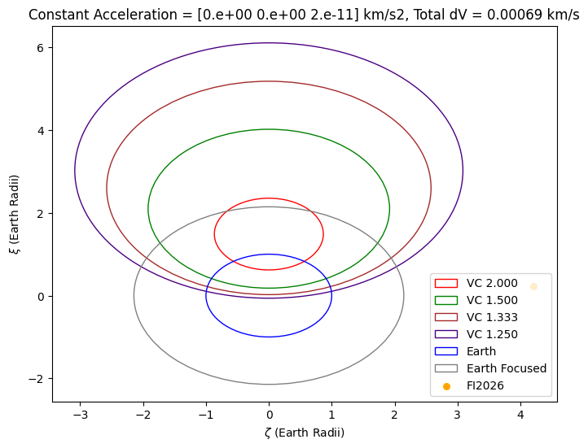

Question 4:
To model a kinetic impact, the velocity of FI2026 is simply adjusted before propagation begins. Velocity was added in the same frame as the earlier continuous acceleration (radial, out of plane, and transverse) and iterated until a distance of 4 Earth radii was achieved. Guass’s planetary equations were used again for propagation, but perturbative accelerations were set to zero. Again, some of the asteroid impact locations are behind the legend. Overall, less total delta-v is needed for kinetic impacts as frontloading velocity changes increases the amount of time it contributes to position changes.
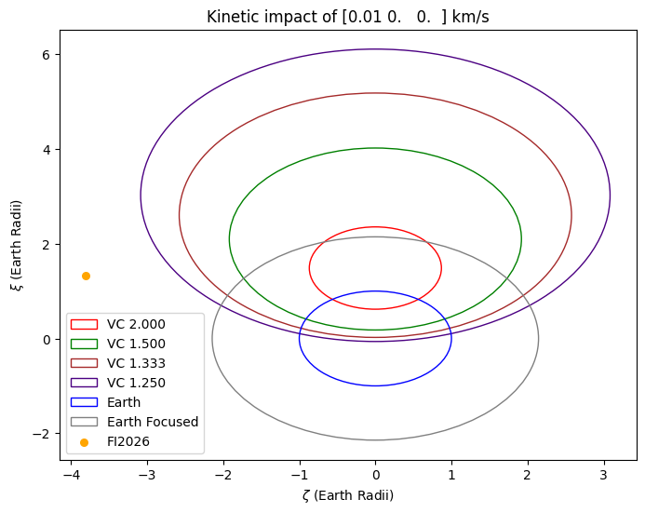
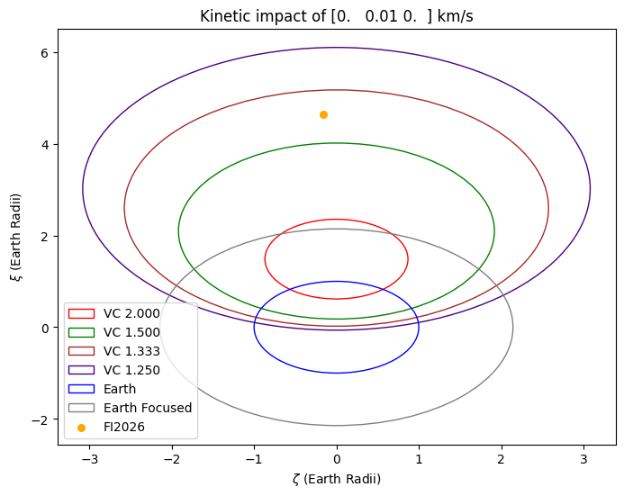
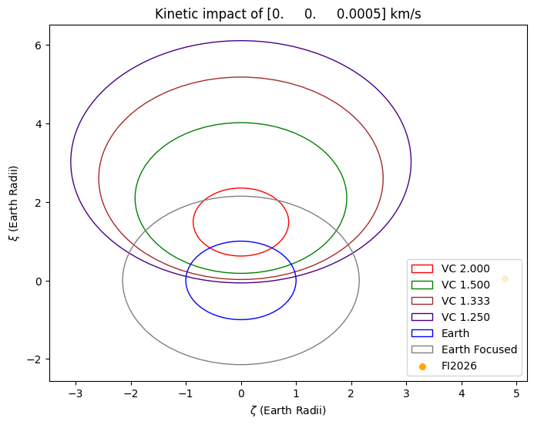
Question 5:
Propagations were done for each direction in the previous two questions. The easiest direction for perturbation is transverse, roughly aligned with the asteroid’s velocity. This makes sense as changing the angular momentum through out of plane acceleration is naturally difficult. For an asteroid the size of Bennu, a Delta-V of 0.5 m/s requires 3.6e10 N of instantaneous force.

Question 6:
Valsecchi circles for 2:1, 3:2, 4:3, 5:4 ratios are plotted in each of the plots above. Only the out of plane velocity changes get close to hitting any of the Valsecchi circles. Radial and transverse velocity move the b-plane intersection to the right or left.

